Write Vitality Log

API called



Context Id

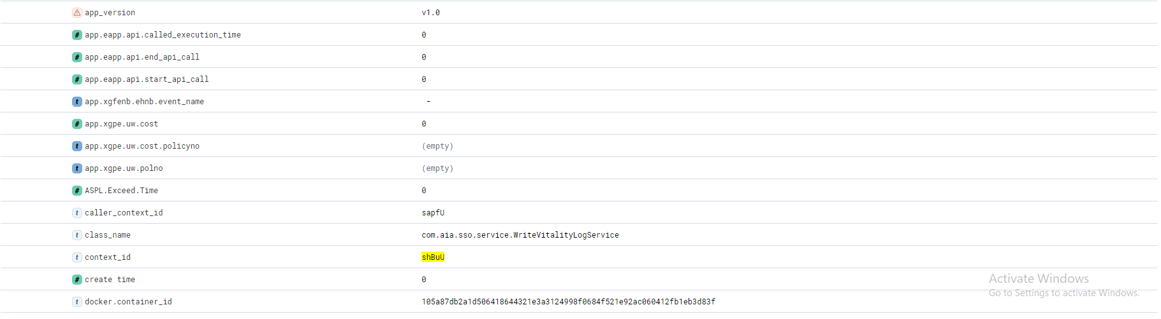

Trace Id

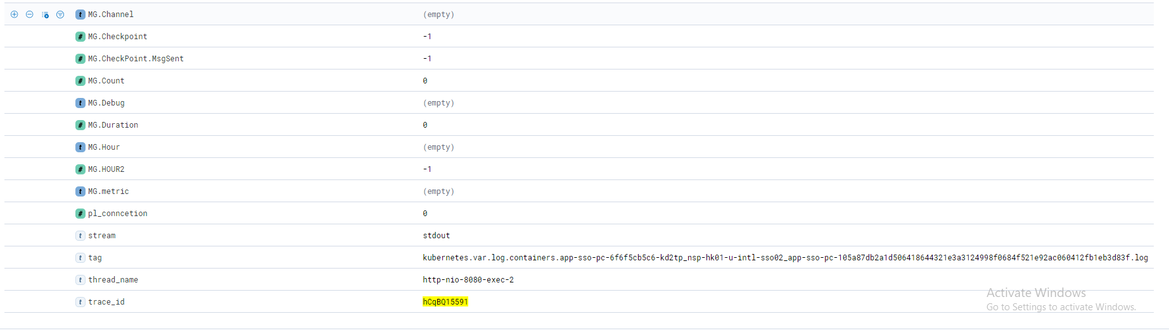

Get QR Code Service

API called



Context Id

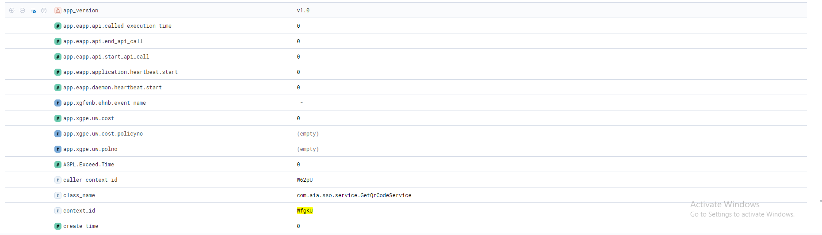

Trace Id

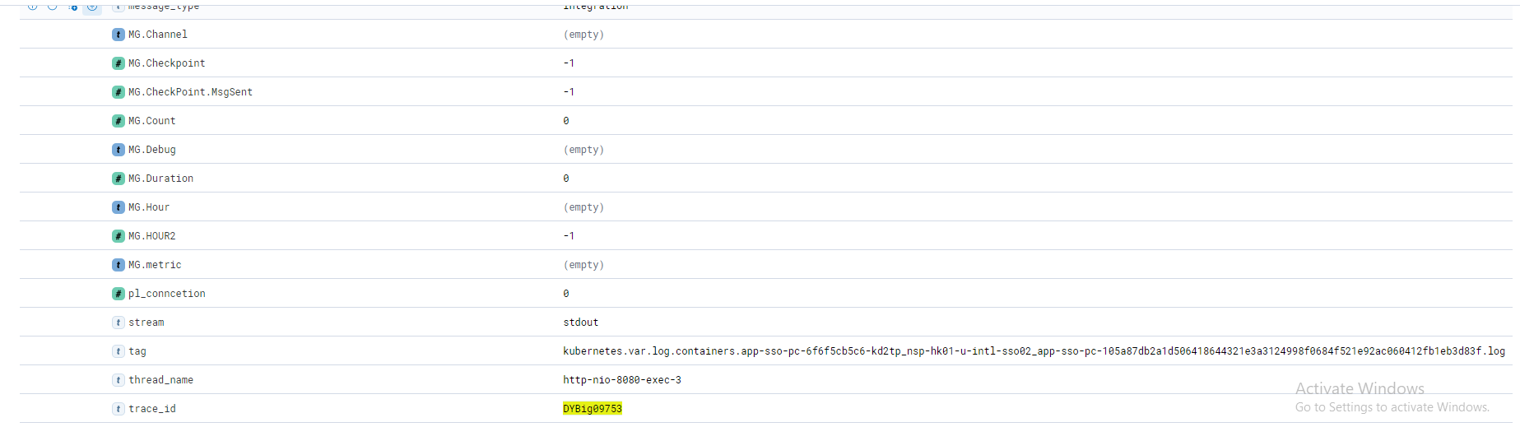

API Called



Context Id

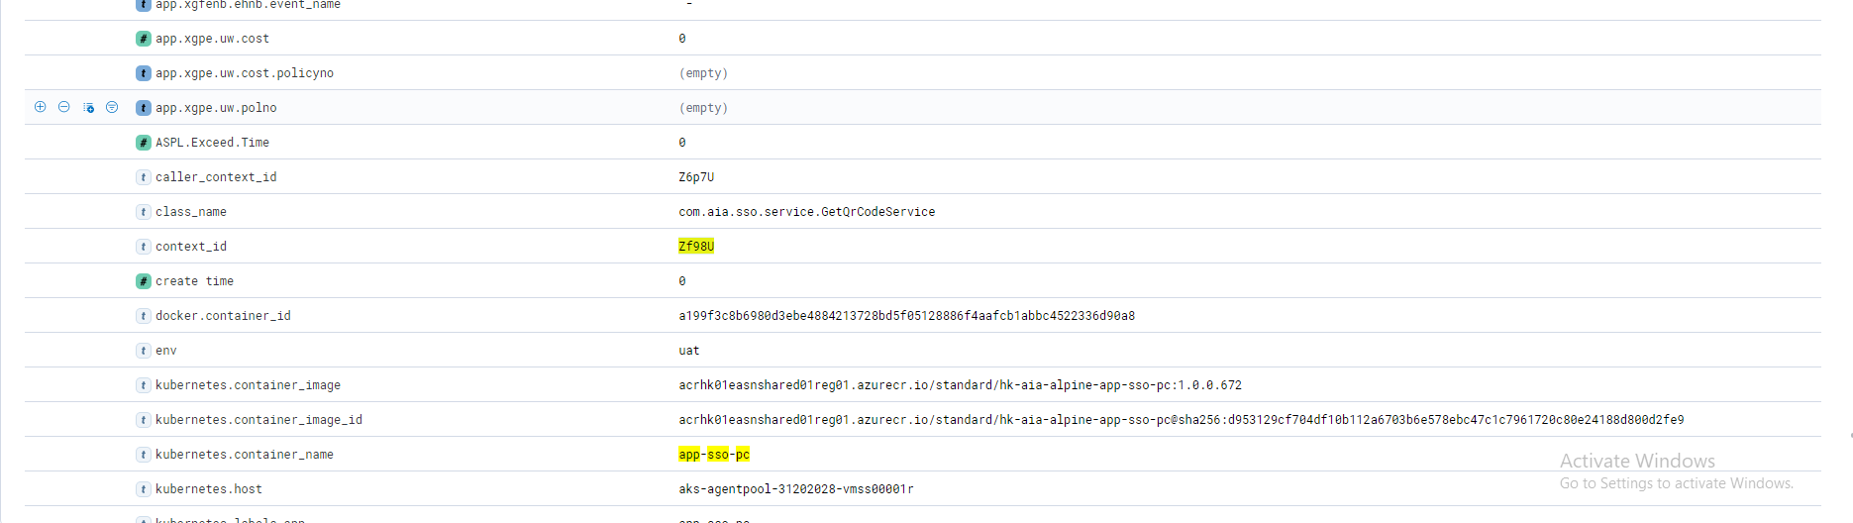

Trace Id

